Iqra Irshad

Execution of Queries against a database to Retrieve, Insert, and Update Data and Creation of EER Diagram showing Relational Database.

MySQL and EER

Assignment 2

Table of Contents

1. **SQL2**

Task 13

Task 13

Task 13

1. **EER3**

Task 13

**SQL**

**Task 1**

* **Using Query 2 you created to change the points to reads times by 10 and plus 100.**

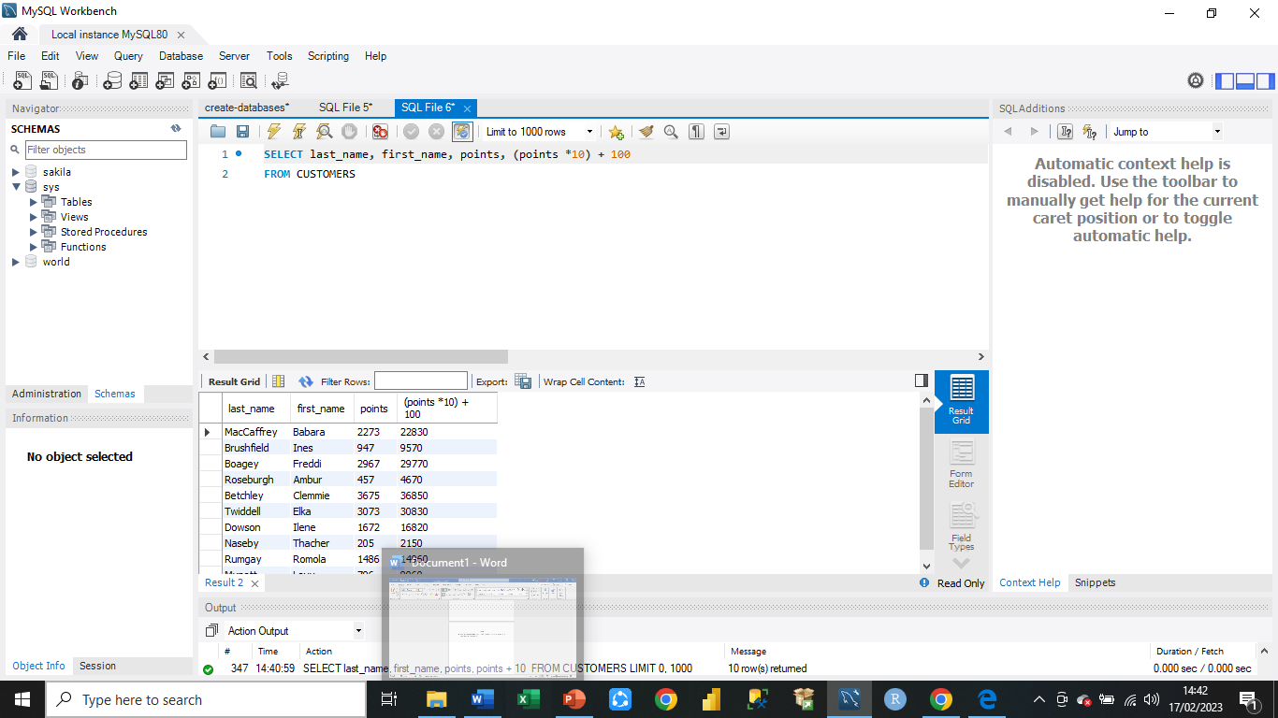

* **Change the Query 2 code to create a discount factor so the table shows a discount header and changes the (point + 10) *100.**

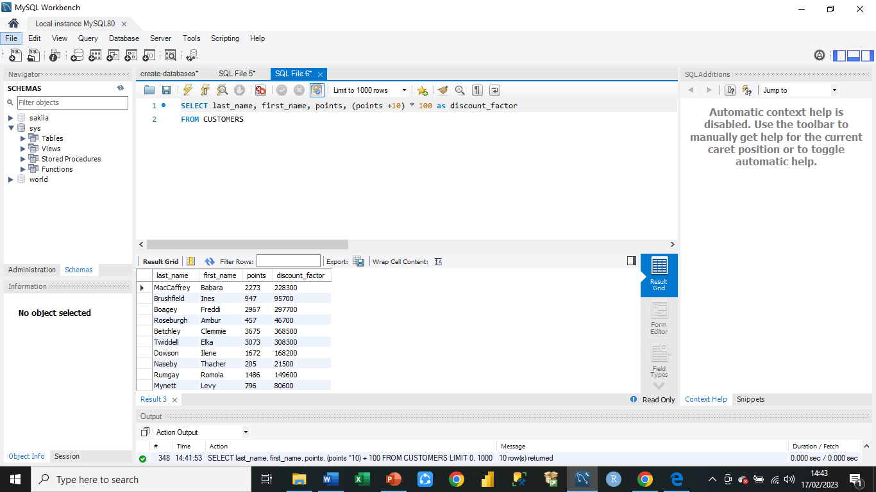

**Task 2**

* **Write a SQL query to return all the products in our database in the result set. I want to make three new columns, name, unit price, and a new price column based on this expression, (unit price * 1.1 ).**

**So what I am doing is increasing the product price of each by 10%.**

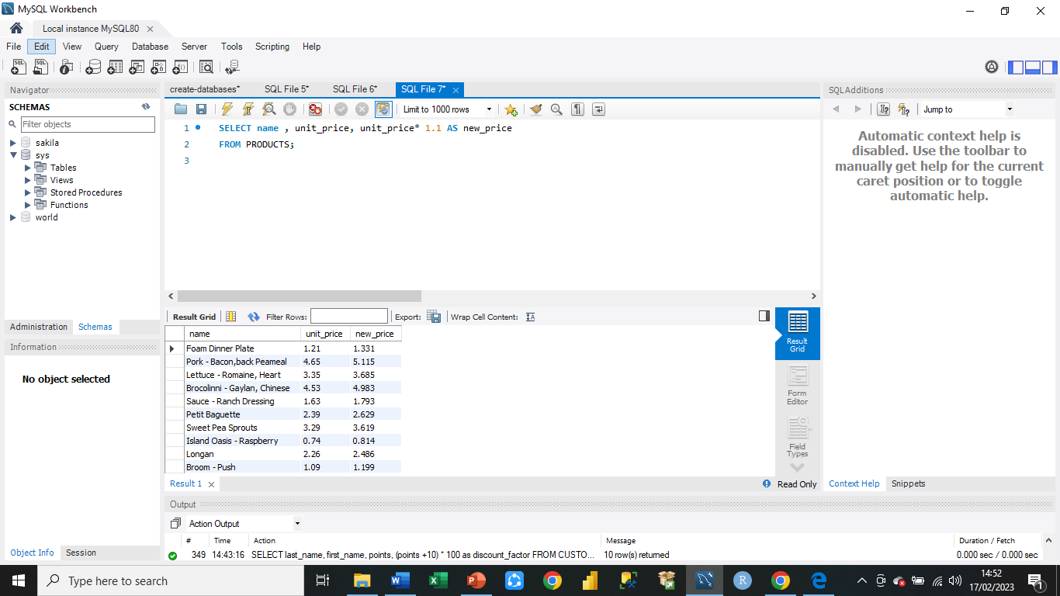

**Another way**

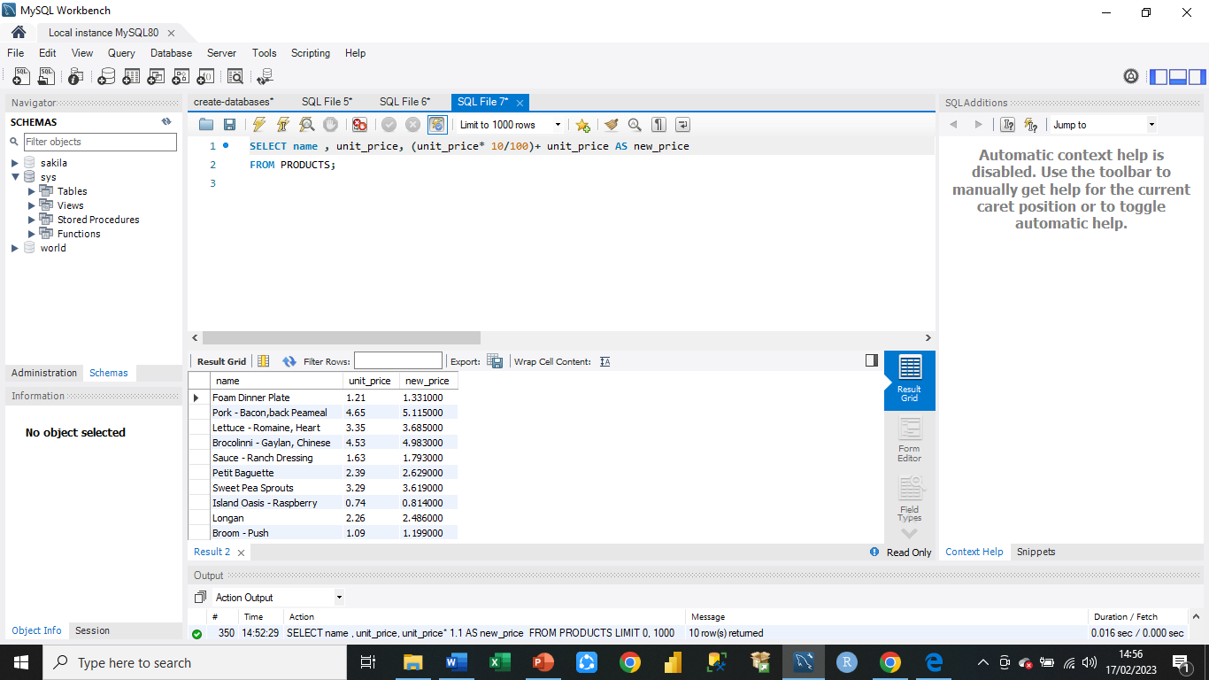

**Task 3**

* **In this task create a new query to find all the customers with a birth date of > '1990-01-01'**

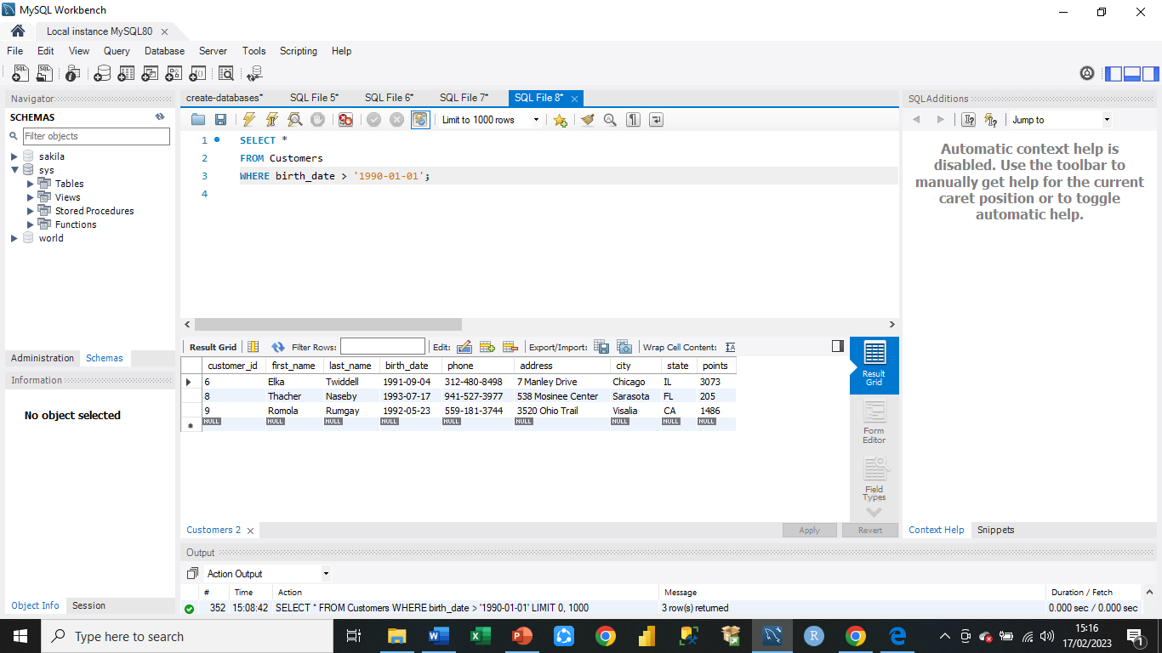

**EER Diagram**

**Task 1**

**EER diagram shows the relationship between Data Frames.**

